**Find My Tutor**

**How to run the project:**

Environment: Visual Studio Community 2017

* Select the .Net 4.6.2 Framework
* Load the tutorMe.sln from the directory included.
  + /tutorMe/tutorMe.sln
* Rebuild the solution.
  + Build >> Rebuild Solution.

Login:

    The first step of using the program is to create an account. From the login page there is a link to the account creation page.

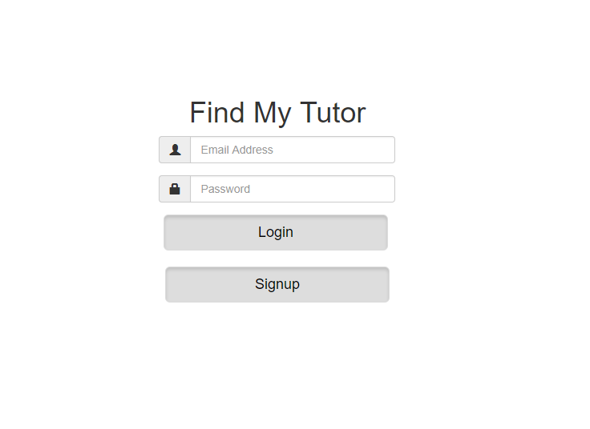

SignUp:

Enter the requested information to create an account. After being redirected to the login page again, enter your login information. After login page you will be redirected to TutorSearch page.

TutorSearch:

    Here you can look at available tutors in all of the classes that currently have tutors registered i.e. for the class you want to look from the left drawer. There is example data in for these tutors. After selecting a tutor, you will be able to view all the information of the tutor and from the Calendar you will be able to view the time slots for which he is available. You will be able to send an email requesting a time to meet a tutor.

UserSettings:

    This page allows users to change their email or password. They also have a Calendar, thus giving the user the option to have time slots to see when he/she is free to get tutored which they can update.

TutorSettings:

    This page allows tutors to change their email or password and can add bio and phone number. Also, they can add class and price for that particular class if that class exists in the database. If the class does not exist, then they have the option to add it and then follow the previous step. All these changes made can be viewed in the table where they have also the option to remove that class. Additionally, they will be able to add free times that they can tutor.

**Overview of Implemented Features**

* Signup Page
* Users are able create a custom account to login to “FindMyTutor”.
* Inputs: first name, last name, matching password and confirm password whose length is between 5 and 16 characters and email address of the form (<some string>@<some domain>.<com, org, etc.>) is required.
* Login Page
  + Users can login to “FindMyTutor”.
  + Inputs: email address of the form (<some string>@<some domain>.<com, org, etc.>) (required) and password whose length is between 5 and 16 characters (required).
* TutorSearch Page
* Users can search for the tutor for a particular class they need tutoring for.
* After selecting a tutor, the user can view that particular tutor’s all information like name, rating, Email, phone and calendar displaying the slots for which the tutor is available for tutoring.
* Inputs: Select a class from the left drawer the other drawer opens and then from there select a tutor from the list of tutors.
* TutorSettings Page
* Tutor has the option to change the login settings by changing the email address of the form (<some string>@<some domain>.<com, org, etc.>) and password whose length is between 5 and 16 characters (required). Additionally, they can add bio and phone number which should be 10 digits (required).
* Tutor has the option to add an existing and non-existing class along with the rate for which he/she wants to tutor for.
* Tutor has the option to update the Calendar by dragging the slots in the calendar for which he/she wants to tutor.
* Tutor has the option to switch to Tutor search page and User settings page.
* Inputs: Enter the email address of the form (<some string>@<some domain>.<com, org, etc.>) and the password whose length is between 5 and 16 characters (required) in “Change Login Settings” and can add bio and phone number which should be 10 digits (required). Add a class from the dropdown and then add rate for that class. Add a non-existing class. Table will be updated with the added classes and prices. Then add class schedule in the calendar.
* UserSettings Page
* Student has the option to change the login settings by changing the email address of the form (<some string>@<some domain>.<com, org, etc.>) and password whose length is between 5 and 16 characters (required).
* Student has the option to add the times he/she wants to get tutored in the calendar.
* Student has the option to switch to Tutor search page and Tutor settings page.
* Inputs:  Enter the email address of the form (<some string>@<some domain>.<com, org, etc.>) and the password whose length is between 5 and 16 characters (required) in “Change Login Settings”. Add the times for which he/she wants to get tutored.